Sign up for free
Sign in

Papers

Search

- Main Navigation
- Get Mendeley
- What is Mendeley?
- Papers
- Groups

Current issues in comparative macrosociology: a debate on methodological issues
by John H Goldthorpe
Social Sciences › Miscellaneous Papers
In your librarySave reference to library
Share

- Share on Facebook
- Share on Twitter
- Email this link

Comparative Social Research (1997)
Volume: 16, Publisher: Sage Publications Ltd, Pages: 1-26
- ISBN: 1412903823
Available from scholar.google.com
or Find this paper at:
- openurl.ac.uk
- WorldCat®
- Google Scholar
- Edit library access links

Abstract
Some superficial critique at QCA.

Related research

Methodological issues in comparative macrosociology
Jack A Goldstonein Comparative Social Research(1997)
2 readersSave reference to library·Related research
- Current Issues in Comparative Macrosociology: A Debate on Methodological Issues ; Comparing Historical Sequences-A Powerful Tool For Causal Analysis: A Reply to Goldthorpe ; Methodological Issues in Comparative Macrosociology ; A Response to the Commentar
John H Rueschemeyer, Dietrich Goldthorpe, John D Goldstone, Jack A Stephensin Comparative Social Research(1997)
1 readerSave reference to library·Related research
- THE REVIVAL OF MACROSOCIOLOGY - METHODOLOGICAL ISSUES OF DISCONTINUITY IN COMPARATIVE-HISTORICAL THEORY
Peter Knappin Sociological Forum(1990)
3 readersSave reference to library·Related research
- Comparing Historical Sequences--A Powerful Tool for Causal Analysis: A Reply to John Goldthorpe's "Current Issues in Comparative Macrosociology"
Dietrich Rueschemeyer, John D Stephensin Comparative Social Research(1997)
3 readersSave reference to library·Related research
- Current issues in the hermeneutics debate
Bernard C Lateganin Neotestamentica(1984)
1 readerSave reference to library·Related research
More related papers

Cite this document ^{(BETA)}
- APA
- BibTeX
- Cell
- Chicago
- Harvard
- MLA
- Nature
- Science
Choose a citation style from the tabs above.

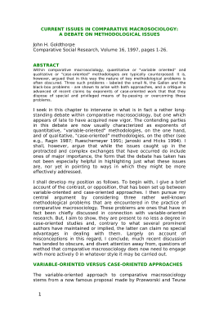Click to zoom in 2 pages available to preview
Available from scholar.google.com
Close
Page 1
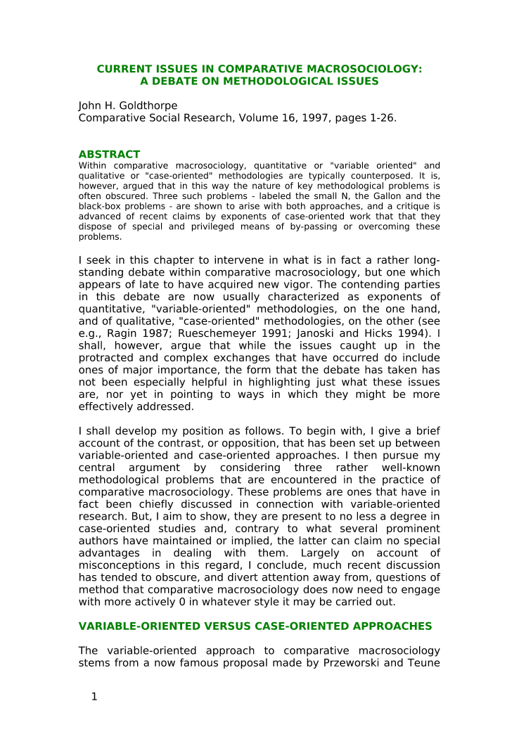

CURRENT ISSUES IN COMPARATIVE MACROSOCIOLOGY:
A DEBATE ON METHODOLOGICAL ISSUES
John H. Goldthorpe
Comparative Social Research, Volume 16, 1997, pages 1-26.
ABSTRACT
Within comparative macrosociology, quantitative or "variable oriented" and
qualitative or "case-oriented" methodologies are typically counterposed. It is,
however, argued that in this way the nature of key methodological problems is
often obscured. Three such problems - labeled the small N, the Gallon and the
black-box problems - are shown to arise with both approaches, and a critique is
advanced of recent claims by exponents of case-oriented work that that they
dispose of special and privileged means of by-passing or overcoming these
problems.
I seek in this chapter to intervene in what is in fact a rather long-
standing debate within comparative macrosociology, but one which
appears of late to have acquired new vigor. The contending parties
in this debate are now usually characterized as exponents of
quantitative, "variable-oriented" methodologies, on the one hand,
and of qualitative, "case-oriented" methodologies, on the other (see
e.g., Ragin 1987; Rueschemeyer 1991; Janoski and Hicks 1994). I
shall, however, argue that while the issues caught up in the
protracted and complex exchanges that have occurred do include
ones of major importance, the form that the debate has taken has
not been especially helpful in highlighting just what these issues
are, nor yet in pointing to ways in which they might be more
effectively addressed.
I shall develop my position as follows. To begin with, I give a brief
account of the contrast, or opposition, that has been set up between
variable-oriented and case-oriented approaches. I then pursue my
central argument by considering three rather well-known
methodological problems that are encountered in the practice of
comparative macrosociology. These problems are ones that have in
fact been chiefly discussed in connection with variable-oriented
research. But, I aim to show, they are present to no less a degree in
case-oriented studies and, contrary to what several prominent
authors have maintained or implied, the latter can claim no special
advantages in dealing with them. Largely on account of
misconceptions in this regard, I conclude, much recent discussion
has tended to obscure, and divert attention away from, questions of
method that comparative macrosociology does now need to engage
with more actively 0 in whatever style it may be carried out.
VARIABLE-ORIENTED VERSUS CASE-ORIENTED APPROACHES
The variable-oriented approach to comparative macrosociology
stems from a now famous proposal made by Przeworski and Teune
1
Page 2
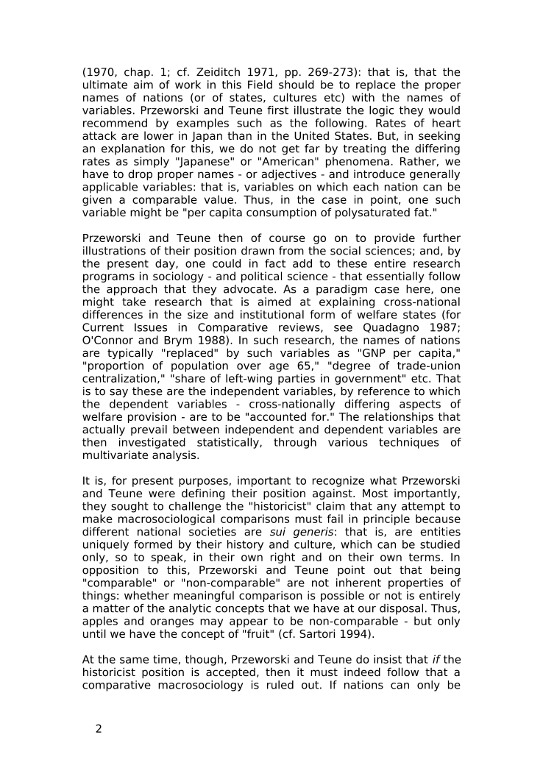
(1970, chap. 1; cf. Zeiditch 1971, pp. 269-273): that is, that the
ultimate aim of work in this Field should be to replace the proper
names of nations (or of states, cultures etc) with the names of
variables. Przeworski and Teune first illustrate the logic they would
recommend by examples such as the following. Rates of heart
attack are lower in Japan than in the United States. But, in seeking
an explanation for this, we do not get far by treating the differing
rates as simply "Japanese" or "American" phenomena. Rather, we
have to drop proper names - or adjectives - and introduce generally
applicable variables: that is, variables on which each nation can be
given a comparable value. Thus, in the case in point, one such
variable might be "per capita consumption of polysaturated fat."
Przeworski and Teune then of course go on to provide further
illustrations of their position drawn from the social sciences; and, by
the present day, one could in fact add to these entire research
programs in sociology - and political science - that essentially follow
the approach that they advocate. As a paradigm case here, one
might take research that is aimed at explaining cross-national
differences in the size and institutional form of welfare states (for
Current Issues in Comparative reviews, see Quadagno 1987;
O'Connor and Brym 1988). In such research, the names of nations
are typically "replaced" by such variables as "GNP per capita,"
"proportion of population over age 65," "degree of trade-union
centralization," "share of left-wing parties in government" etc. That
is to say these are the independent variables, by reference to which
the dependent variables - cross-nationally differing aspects of
welfare provision - are to be "accounted for." The relationships that
actually prevail between independent and dependent variables are
then investigated statistically, through various techniques of
multivariate analysis.
It is, for present purposes, important to recognize what Przeworski
and Teune were defining their position against. Most importantly,
they sought to challenge the "historicist" claim that any attempt to
make macrosociological comparisons must fail in principle because
different national societies are sui generis: that is, are entities
uniquely formed by their history and culture, which can be studied
only, so to speak, in their own right and on their own terms. In
opposition to this, Przeworski and Teune point out that being
"comparable" or "non-comparable" are not inherent properties of
things: whether meaningful comparison is possible or not is entirely
a matter of the analytic concepts that we have at our disposal. Thus,
apples and oranges may appear to be non-comparable - but only
until we have the concept of "fruit" (cf. Sartori 1994).
At the same time, though, Przeworski and Teune do insist that if the
historicist position is accepted, then it must indeed follow that a
comparative macrosociology is ruled out. If nations can only be
2

